Coming off the Project Pitch, I wanted to make the Major Project in unity as well. Again, time was my greatest enemy here, as I quickly ran down the clock simply learning the intricacies of Unity. To finish the assignment by the deadline, I made the switch back to Twine, but this time with Sugarcube rather than Harlowe. With Sugarcube, I was able to write twee files directly and compile them into the project with Tweego. By doing this I was even able to set up a healthy file architecture to keep everything far more organized than in my Minor Project. (This can be viewed in the Major Folder directory on Github, *not the .zip version*)

1: Flintlock I was modeling in Blender as an asset for the game

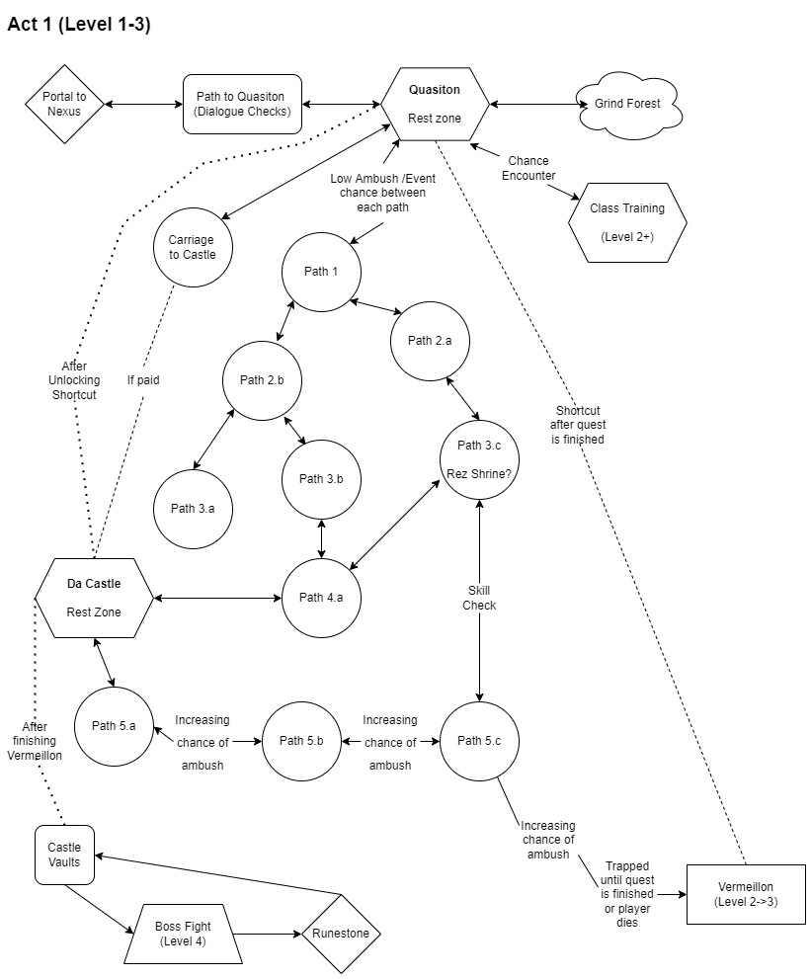

2: The original story map for the first Act before I condensed the game